**Multiple linear regression**

import numpy as np

import pandas as pd

dataset = pd.read_csv('50_Startups.csv')

X = dataset.iloc[:, :-1]

y = dataset.iloc[:, 4]

states=pd.get_dummies(X['State'],drop_first=True)

X=X.drop('State',axis=1)

X=pd.concat([states,X],axis=1)

from sklearn.model_selection import train_test_split

X_train, X_test, y_train, y_test = train_test_split(X, y, test_size = 0.2, random_state = 0)

from sklearn.linear_model import LinearRegression

regressor = LinearRegression()

regressor.fit(X_train, y_train)

y_pred = regressor.predict(X_test)

from sklearn.metrics import r2_score

score=r2_score(y_test,y_pred)

print('Accuracy R2 Score',score)

import statsmodels.api as sm

X = np.append(arr = np.ones((50, 1)).astype(int), values = X, axis = 1)

X_opt = X[:, [0, 1, 2, 3, 4, 5]]

regressor_OLS = sm.OLS( y, X_opt).fit()

print(regressor_OLS.summary())

X_opt = X[:, [0, 1, 3, 4, 5]]

regressor_OLS = sm.OLS( y, X_opt).fit()

print(regressor_OLS.summary())

X_opt = X[:, [0, 3, 4, 5]]

regressor_OLS = sm.OLS( y, X_opt).fit()

print(regressor_OLS.summary())

X_opt = X[:, [0, 3, 5]]

regressor_OLS = sm.OLS(y, X_opt).fit()

print(regressor_OLS.summary())

X_opt = X[:, [0, 3]]

regressor_OLS = sm.OLS(endog = y, exog = X_opt).fit()

print(regressor_OLS.summary())

**Apriori Algorithm**

import numpy as np

import matplotlib.pyplot as plt

import pandas as pd

dataset = pd.read_csv('Market_Basket_Optimisation.csv', low_memory=False, header=None)

!pip install apyori

list_of_transactions = []

for i in range(0, 7501):

list_of_transactions.append([str(dataset.values[i,j]) for j in range(0, 20)])

list_of_transactions[0]

from apyori import apriori

rules = apriori(list_of_transactions, min_support = 0.004, min_confidence = 0.2, min_lift = 3, min_length = 2)

results = list(rules)

def inspect(results):

lhs = [tuple(result [2] [0] [0]) [0] for result in results]

rhs = [tuple(result [2] [0] [1]) [0] for result in results]

supports = [result [1] for result in results]

confidences = [result [2] [0] [2] for result in results]

lifts = [result [2] [0] [3] for result in results]

return list(zip(lhs,rhs,supports,confidences, lifts))

resultsinDataFrame = pd.DataFrame(inspect(results),columns = ['Left Hand Side', 'Right Hand Side', 'Support', 'Confidence', 'Lift'] )

resultsinDataFrame.head(10)

**K-Means Clustering Algorithm**

from sklearn.datasets import load_iris

from itertools import cycle

from sklearn.decomposition import PCA

from sklearn.cluster import KMeans

from numpy.random import RandomState

import pylab as pl

import matplotlib.pyplot as plt

class clustering:

def __init__(self):

self.plot(load_iris().data)

def plot(self, X):

wcss=[]

for i in range(1,11):

kmeans=KMeans(n_clusters=i,init='k-means++',max_iter=300,n_init=10,random_state=0)

kmeans.fit(X)

wcss.append(kmeans.inertia_)

plt.plot(range(1,11),wcss)

plt.title('Elbow Method')

plt.xlabel('Number of Clusters')

plt.ylabel('WCSS')

plt.show()

pca = PCA(n_components=2, whiten=True).fit(X)

X_pca = pca.transform(X)

kmeans = KMeans(n_clusters=3, random_state=RandomState(42)).fit(X_pca)

plot_2D(X_pca, kmeans.labels_, ["c0", "c1", "c2"])

def plot_2D(data, target, target_names):

colors = cycle('rgbcmykw')

target_ids = range(len(target_names))

pl.figure()

for i, c, label in zip(target_ids, colors, target_names):

pl.scatter(data[target == i, 0], data[target == i, 1],

c=c, label=label)

pl.legend()

pl.show()

if __name__ == '__main__':

c = clustering()

**K Nearest Neighbour algorithm**

import numpy as np

import matplotlib.pyplot as plt

import pandas as pd

dataset = pd.read_csv('Social_Network_Ads.csv')

X = dataset.iloc[:, [2, 3]].values

y = dataset.iloc[:, 4].values

from sklearn.model_selection import train_test_split

X_train, X_test, y_train, y_test = train_test_split(X, y, test_size = 0.25, random_state = 0)

from sklearn.preprocessing import StandardScaler

sc = StandardScaler()

X_train = sc.fit_transform(X_train)

X_test = sc.transform(X_test)

from sklearn.neighbors import KNeighborsClassifier

classifier = KNeighborsClassifier(n_neighbors = 5, metric = 'minkowski', p = 2)

classifier.fit(X_train, y_train)

y_pred = classifier.predict(X_test)

from sklearn.metrics import confusion_matrix

cm = confusion_matrix(y_test, y_pred)

print("Confusion Matrix of KNN \n",cm)

from matplotlib.colors import ListedColormap

X_set, y_set = X_train, y_train

X1, X2 = np.meshgrid(np.arange(start = X_set[:, 0].min() - 1, stop = X_set[:, 0].max() + 1, step = 0.01),

np.arange(start = X_set[:, 1].min() - 1, stop = X_set[:, 1].max() + 1, step = 0.01))

plt.contourf(X1, X2, classifier.predict(np.array([X1.ravel(), X2.ravel()]).T).reshape(X1.shape),

alpha = 0.75, cmap = ListedColormap(('red', 'green')))

plt.xlim(X1.min(), X1.max())

plt.ylim(X2.min(), X2.max())

for i, j in enumerate(np.unique(y_set)):

plt.scatter(X_set[y_set == j, 0], X_set[y_set == j, 1],

c = ListedColormap(('red', 'green'))(i), label = j)

plt.title('K-NN (Training set)')

plt.xlabel('Age')

plt.ylabel('Estimated Salary')

plt.legend()

plt.show()

from matplotlib.colors import ListedColormap

X_set, y_set = X_test, y_test

X1, X2 = np.meshgrid(np.arange(start = X_set[:, 0].min() - 1, stop = X_set[:, 0].max() + 1, step = 0.01),

np.arange(start = X_set[:, 1].min() - 1, stop = X_set[:, 1].max() + 1, step = 0.01))

plt.contourf(X1, X2, classifier.predict(np.array([X1.ravel(), X2.ravel()]).T).reshape(X1.shape),

alpha = 0.75, cmap = ListedColormap(('red', 'green')))

plt.xlim(X1.min(), X1.max())

plt.ylim(X2.min(), X2.max())

for i, j in enumerate(np.unique(y_set)):

plt.scatter(X_set[y_set == j, 0], X_set[y_set == j, 1],

c = ListedColormap(('red', 'green'))(i), label = j)

plt.title('K-NN (Test set)')

plt.xlabel('Age')

plt.ylabel('Estimated Salary')

plt.legend()

plt.show()

score = classifier.score(X_test, y_test)

print('Accuracy Score is: ',score)

**Hierarchical Clustering Algorithm**

import matplotlib.pyplot as plt

import pandas as pd

dataset = pd.read_csv('Mall_Customers.csv')

X = dataset.iloc[:, [3, 4]].values

import scipy.cluster.hierarchy as sch

dendrogram = sch.dendrogram(sch.linkage(X, method = 'ward'))

plt.title('Dendrogram')

plt.xlabel('Customers')

plt.ylabel('Euclidean distances')

plt.axhline(y=200, color='r', linestyle='--')

plt.show()

from sklearn.cluster import AgglomerativeClustering

hc = AgglomerativeClustering(n_clusters = 5, affinity = 'euclidean', linkage = 'ward')

y_hc = hc.fit_predict(X)

plt.scatter(X[y_hc == 0, 0], X[y_hc == 0, 1], s = 100, c = 'red', label = 'Cluster 1')

plt.scatter(X[y_hc == 1, 0], X[y_hc == 1, 1], s = 100, c = 'blue', label = 'Cluster 2')

plt.scatter(X[y_hc == 2, 0], X[y_hc == 2, 1], s = 100, c = 'green', label = 'Cluster 3')

plt.scatter(X[y_hc == 3, 0], X[y_hc == 3, 1], s = 100, c = 'cyan', label = 'Cluster 4')

plt.scatter(X[y_hc == 4, 0], X[y_hc == 4, 1], s = 100, c = 'magenta', label = 'Cluster 5')

plt.title('Clusters of customers')

plt.xlabel('Annual Income (k$)')

plt.ylabel('Spending Score (1-100)')

plt.legend()

plt.show()

**Random Forest Classification**

import numpy as np

import matplotlib.pyplot as plt

import pandas as pd

dataset = pd.read_csv('Social_Network_Ads.csv')

X = dataset.iloc[:, [2, 3]].values

y = dataset.iloc[:, 4].values

from sklearn.model_selection import train_test_split

X_train, X_test, y_train, y_test = train_test_split(X, y, test_size = 0.25, random_state = 0)

from sklearn.preprocessing import StandardScaler

sc = StandardScaler()

X_train = sc.fit_transform(X_train)

X_test = sc.transform(X_test)

from sklearn.ensemble import RandomForestClassifier

classifier = RandomForestClassifier(n_estimators = 10, criterion = 'entropy', random_state = 0)

classifier.fit(X_train, y_train)

y_pred = classifier.predict(X_test)

from sklearn.metrics import confusion_matrix

cm = confusion_matrix(y_test, y_pred)

print(cm)

from matplotlib.colors import ListedColormap

X_set, y_set = X_train, y_train

X1, X2 = np.meshgrid(np.arange(start = X_set[:, 0].min() - 1, stop = X_set[:, 0].max() + 1, step = 0.01),

np.arange(start = X_set[:, 1].min() - 1, stop = X_set[:, 1].max() + 1, step = 0.01))

plt.contourf(X1, X2, classifier.predict(np.array([X1.ravel(), X2.ravel()]).T).reshape(X1.shape),

alpha = 0.75, cmap = ListedColormap(('red', 'green')))

plt.xlim(X1.min(), X1.max())

plt.ylim(X2.min(), X2.max())

for i, j in enumerate(np.unique(y_set)):

plt.scatter(X_set[y_set == j, 0], X_set[y_set == j, 1],

c = ListedColormap(('red', 'green'))(i), label = j)

plt.title('Random Forest Classification (Training set)')

plt.xlabel('Age')

plt.ylabel('Estimated Salary')

plt.legend()

plt.show()

from matplotlib.colors import ListedColormap

X_set, y_set = X_test, y_test

X1, X2 = np.meshgrid(np.arange(start = X_set[:, 0].min() - 1, stop = X_set[:, 0].max() + 1, step = 0.01),

np.arange(start = X_set[:, 1].min() - 1, stop = X_set[:, 1].max() + 1, step = 0.01))

plt.contourf(X1, X2, classifier.predict(np.array([X1.ravel(), X2.ravel()]).T).reshape(X1.shape),

alpha = 0.75, cmap = ListedColormap(('red', 'green')))

plt.xlim(X1.min(), X1.max())

plt.ylim(X2.min(), X2.max())

for i, j in enumerate(np.unique(y_set)):

plt.scatter(X_set[y_set == j, 0], X_set[y_set == j, 1],

c = ListedColormap(('red', 'green'))(i), label = j)

plt.title('Random Forest Classification (Test set)')

plt.xlabel('Age')

plt.ylabel('Estimated Salary')

plt.legend()

plt.show()

**CART algorithm**

from sklearn import tree

from sklearn.datasets import load_iris

iris = load_iris()

clf = tree.DecisionTreeClassifier()

clf = clf.fit(iris.data, iris.target)

import graphviz

dot_data = tree.export_graphviz(clf, out_file=None)

graph = graphviz.Source(dot_data)

graph.render("iriscart")

dot_data = tree.export_graphviz(clf, out_file=None,

feature_names=iris.feature_names,

class_names=iris.target_names,

filled=True, rounded=True,

special_characters=True)

graph = graphviz.Source(dot_data)

graph.view()

**Logistic regression using sigmoid function**

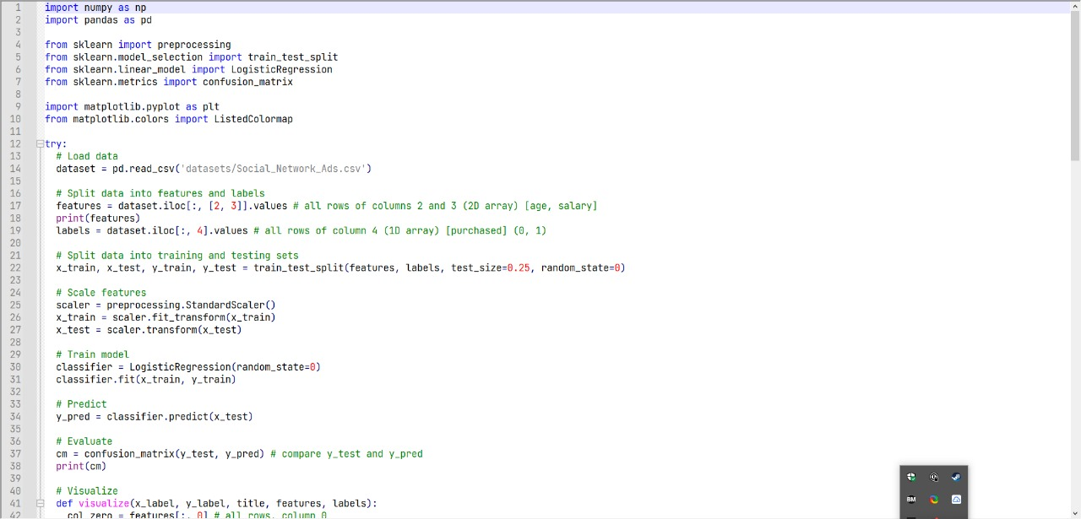

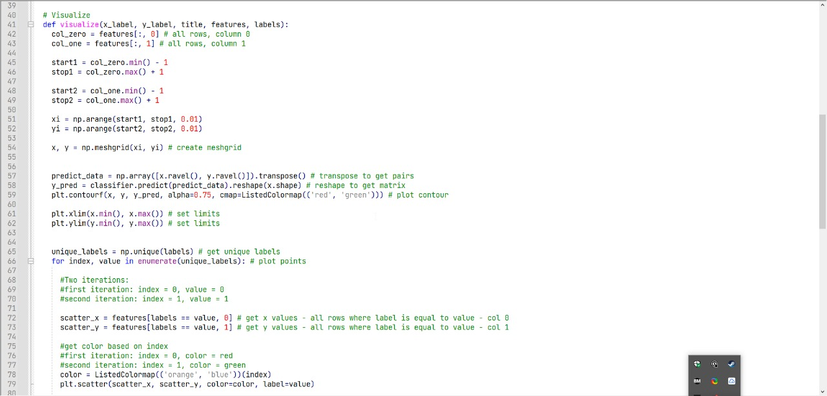

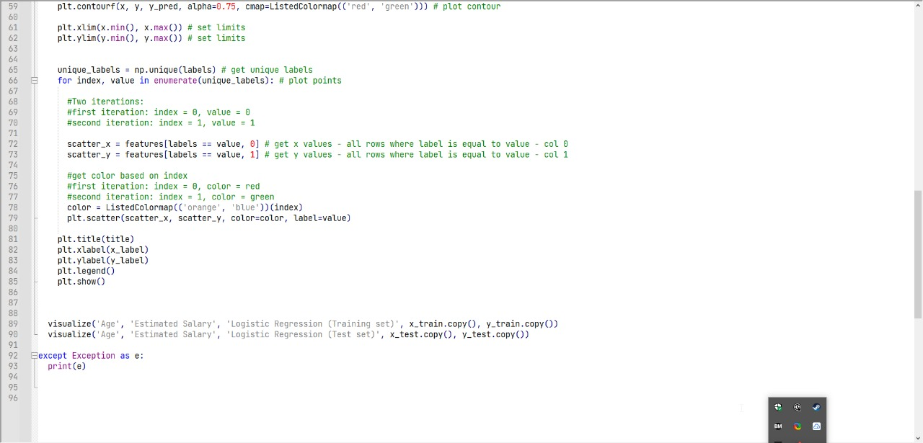

**Support vector machine algorithm using various kernel functions.**

import numpy as np

import matplotlib.pyplot as plt

import pandas as pd

# Importing the dataset

dataset = pd.read_csv('Social_Network_Ads.csv')

X = dataset.iloc[:, [2, 3]].values

y = dataset.iloc[:, 4].values

# Splitting the dataset into the Training set and Test set

from sklearn.model_selection import train_test_split

X_train, X_test, y_train, y_test = train_test_split(X, y, test_size = 0.25, random_state = 0)

# Feature Scaling

from sklearn.preprocessing import StandardScaler

sc = StandardScaler()

X_train = sc.fit_transform(X_train)

X_test = sc.transform(X_test)

# Fitting Kernel SVM to the Training set

from sklearn.svm import SVC

classifier = SVC(kernel = 'rbf', random_state = 0)

#classifier = SVC(kernel = 'linear', random_state = 0)

#from sklearn.svm import LinearSVC

#classifier = LinearSVC( random_state = 0)

#classifier = SVC(kernel = 'poly', random_state = 0)

classifier.fit(X_train, y_train)

# Predicting the Test set results

y_pred = classifier.predict(X_test)

# Making the Confusion Matrix

from sklearn.metrics import confusion_matrix

cm = confusion_matrix(y_test, y_pred)

print("Confusion Matrix of SVM \n",cm)

# Visualising the Training set results

from matplotlib.colors import ListedColormap

X_set, y_set = X_train, y_train

X1, X2 = np.meshgrid(np.arange(start = X_set[:, 0].min() - 1, stop = X_set[:, 0].max() + 1, step = 0.01),

np.arange(start = X_set[:, 1].min() - 1, stop = X_set[:, 1].max() + 1, step = 0.01))

plt.contourf(X1, X2, classifier.predict(np.array([X1.ravel(), X2.ravel()]).T).reshape(X1.shape),

alpha = 0.75, cmap = ListedColormap(('red', 'green')))

plt.xlim(X1.min(), X1.max())

plt.ylim(X2.min(), X2.max())

for i, j in enumerate(np.unique(y_set)):

plt.scatter(X_set[y_set == j, 0], X_set[y_set == j, 1],

c = ListedColormap(('red', 'green'))(i), label = j)

plt.title('Kernel SVM (Training set)')

plt.xlabel('Age')

plt.ylabel('Estimated Salary')

plt.legend()

plt.show()

# Visualising the Test set results

from matplotlib.colors import ListedColormap

X_set, y_set = X_test, y_test

X1, X2 = np.meshgrid(np.arange(start = X_set[:, 0].min() - 1, stop = X_set[:, 0].max() + 1, step = 0.01),

np.arange(start = X_set[:, 1].min() - 1, stop = X_set[:, 1].max() + 1, step = 0.01))

plt.contourf(X1, X2, classifier.predict(np.array([X1.ravel(), X2.ravel()]).T).reshape(X1.shape),

alpha = 0.75, cmap = ListedColormap(('red', 'green')))

plt.xlim(X1.min(), X1.max())

plt.ylim(X2.min(), X2.max())

for i, j in enumerate(np.unique(y_set)):

plt.scatter(X_set[y_set == j, 0], X_set[y_set == j, 1],

c = ListedColormap(('red', 'green'))(i), label = j)

plt.title('Kernel SVM (Test set)')

plt.xlabel('Age')

plt.ylabel('Estimated Salary')

plt.legend()

plt.show()

score = classifier.score(X_test, y_test)

print('Accuracy Score is: ',score)